Are You Seeking  Peace?  A Retreat On  Nonviolence For  College Students | 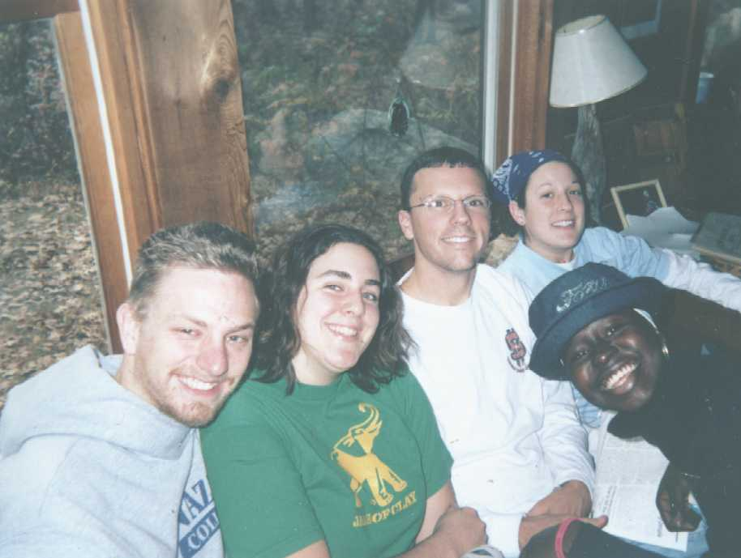

November 4-6 , 2005

Escape for a retreat weekend from the stress of college life and build community with other students searching for peace. Come to a quiet place to think and reflect on Christ's message of nonviolence. Join other students who are willing to risk reflecting on the issues of our day. Share your gifts and enjoy nature amid the stillness of the New England woods. Experience a straw bale house, solar energy, vegetable-fueled car.

The retreat will include—provocative discussions on nonviolence; liturgies; prayer; silence; meditative walks in the woods, poetry, song, and celebration with an evening coffee house. Bring your instruments and poetry.

The setting—We are a Catholic Christian community, ecumenical and interfaith in our embrace. We are located on 32 acres of land in Central Massachusetts next to the natural beauty of the Quabbin Reservoir. Agape is dedicated to a life of Christian nonviolence, simplicity and prayer. All are welcome. Scholarships.

WHAT OTHERS HAVE SAID ABOUT THE RETREAT:

"The students are still talking about this retreat…and several have been motivated to do some different things with their lives." Heather Colonnese, Campus Minister, Le Moyne College 2002

"I learned a lot about myself. I appreciated the time I spent at Agape because I had quality time to think about my life and future…and also I had time to pray for my family, friends and for all those less fortunate." Alethea Henry, College of Mount Saint Vincent, 2000

"The retreat gave me a really hopeful feeling. It reminded me that there really are a lot of thoughtful, prayerful and wonderful people all around me. Building a more nonviolent and just future doesn't seem so impossible to me anymore." Simon Doolittle, UMASS-Amherst, 1999

Register now--$70 ($35 deposit)
Scholarships often available through Campus Ministry

Please fill out the form below and return to: AGAPE, 2062 Greenwich Rd., Ware, MA, 01082 Phone: 413-967-9369, www.agapecommunity.org, peace@agapecommunity.org

Name College
Address
Phone Deposit Enclosed $

