Councillor Reeves
WELCOMES YOU

To a College Student Evening!
What would you like to know about Cambridge Government?
What would you like to share with him?

Please, Meet the Candidate
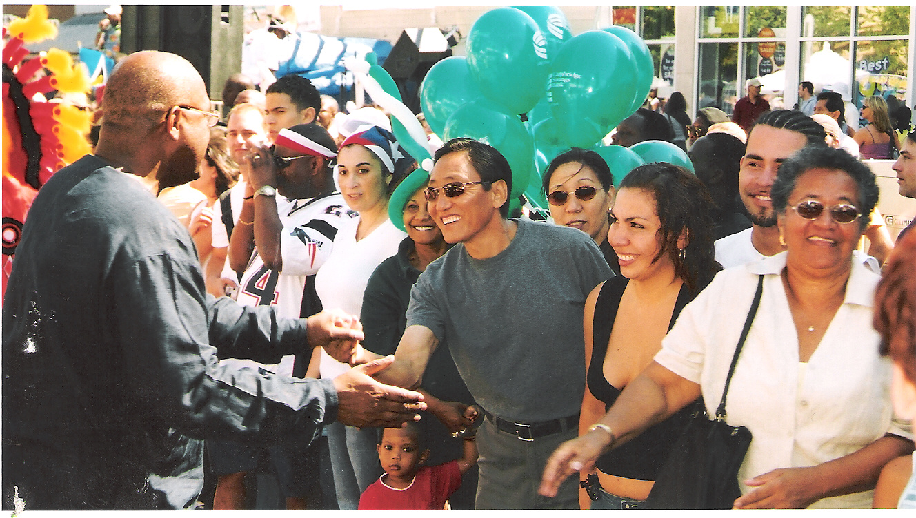
Place: 555 Mass Ave.
Date: Friday, September 30th, 2005
Time: from 7–9pm
 Refreshments Will Be Served 
Food to be provided by the Middle East
Office: | (617)354-0075 | www.KenReeves.org
Gabriel Mondon | (617)828-3835

